SECTION 2:
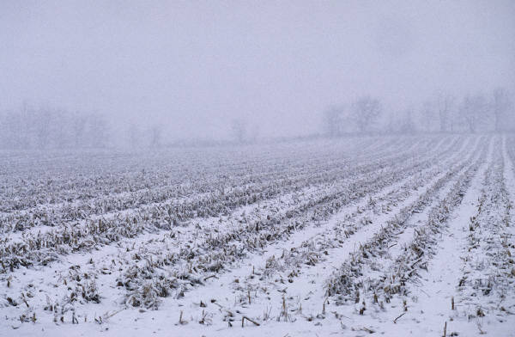ISSUES & OPPORTUNITIES ELEMENT

2.1 SUMMARY

The Town of Rushford, in western Winnebago County, is a community, which strives for preserving values and encouraging opportunities — A community that is citizen supported, and future-oriented. With approximately 1,400 members as part of the Town of Rushford Community and the willingness to accomplish identified goals, the Town of Rushford is in a desirable position to take the next step in the Comprehensive Planning process — the creation of a Town Comprehensive Plan.

In October of 1998, the Town of Rushford contacted the University of Wisconsin-Cooperative Extension Agency to help in the process of land-use planning. With the help of University of Wisconsin-Extension, the Town of Rushford created a Comprehensive Planning Committee including 35 citizens and board members, which would serve as the first step in creating a Town Comprehensive Plan. Since 1998, this partnership has administered a land use opinion survey that identified many citizen concerns and needs, educated citizens regarding Comprehensive Planning purpose and consequences, and most of all, a "Vision" representing the future direction of the Town of Rushford was created. A direction that would entail a 10-20 year horizon.
Through this visioning process, committee members as well as citizens of the Town of Rushford have become sensitive to the impacts of unplanned development that could possibly occur in their community if action is avoided, or even delayed. A vision statement was developed in acordinance with respecting and preserving present and future community values. The vision statement will serve to support and guide future Comprehensive Planning within the Town of Rushford (see Figure 1).
Figure 1 - Town of Rushford Vision Statement
With a vision in place, and community values established, the Comprehensive Planning process can proceed to the next level with the creation of a Town Comprehensive Plan. The process will begin with the development of a Community Profile Report, followed by plan preparation — the Town Comprehensive Plan. The Community Profile Report identifies existing conditions in the town including past and projected growth trends, and the identification of issues and needs. That information is presented in this document. Following the Community Profile Report, is the development of the Town Comprehensive Plan whereby implementation strategies and a future land use map are created.
We Will Achieve…

Open Space Preservation
Using Land Wisely
Rural Atmosphere

Valuing Strong Morals
Inspiring Community Organized Activities
Supporting Farming and Agriculture
Integration of Regional Comprehensive Plans
Our Culture and History be Preserved
Natural Resource Preservation

….through the successful implementation
of an effective Comprehensive Plan that balances community and private property rights.

Rushford Visioning

In any Comprehensive Planning process, it is not only important to evaluate and draft a consensus of community values such as what the Town of Rushford has already accomplished, but it is very important to consider the legal planning framework from which the town has to work under. Various local governments including town governments, in most instances, experience multi-jurisdictional claims on planning authority. Therefore, identifying appropriate levels of planning authority specific to a locality is crucial to the success of any Comprehensive Plan.

Identification of Initial Goals & Objectives

The following goal statements were reviewed and established by the Town of Rushford Comprehensive Planning Committee as a framework for the development of this Comprehensive Plan. Overwhelming support for these goals was gained through public meetings, committee meetings, a citizen survey, and through a Visioning Process conducted by University of Wisconsin-Extension. Noticeably, there is some overlap among goal statements. However, each statement attempts to address a topic in itself. Without any order of importance, the Town of Rushford has identified the following goal statements to function as the basis of their Comprehensive Plan:
1 Promote Water Resources as an Economic Tool while Protecting Wildlife and Aquatic Habitat through Water Traffic Regulation.

The Fox River has long been a great asset to the Town of Rushford, Winnebago County, and the greater Fox River Valley Region. Protecting this natural resource while promoting economic activity in a way that encourages efficient water use and awareness, is an important aspect of rural atmosphere in the Town of Rushford.
2 Conserve and Enhance the Water and Wetland Resources that make the Town of Rushford an Attractive and Healthy Environment to Live and Work in.

Conservation and enhancement of existing water resources can increase recreational opportunities, maintain and expand wildlife natural habitats, and also discourage improper land use practices on adjacent lands.
6 Preserve our Historic Landmarks and Culture.

Large tracts of land primarily used for Agricultural purposes exist within the Town of Rushford. These tracts provide open space very desirable to the Town of Rushford. To maintain rural character in the Town of Rushford is to recognize opportunities of preserving this open space by encouraging the use of farming and protection of natural resources.
7 Encourage Open Space Preservation and the Efficient Use of Land through the Proper Placement of Development on the Landscape and the use of Tools such as Clustering and Maximum Lot Sizes.

3 Preserve the Open Space that Defines the Town of Rushford's Rural Character.

Cluster development is a means of directing new construction to areas already developed. The unincorporated areas of Waukau, Eureka, and Delhi are areas in Rushford which contain a majority of housing units and public facilities. In order to preserve existing land mass in the Town of Rushford, would be to manage development so that it occurs in these already developed areas. Coordinated development patterns also enhances fiscal capacities of local governments.
4 Manage Development so that it Occurs Near Already Developed Areas (ie; Waukau, Eureka, Delhi).

5 Direct Development into the Areas Most Developable.

Likewise, development should not occur in environmentally significant areas or areas where prime farmland exist. Areas which already contain residential or non-residential development, that are not within a floodplain or wetland area, are areas where future development should be designated.

The Town of Rushford is a unique place to live because of its character, its physical attributes, and its history. Recognizing the historical and cultural significance of Rushford is the first step in preserving the past, present, and future identity of the Town of Rushford.

The Town of Rushford recognizes that proper placement of new construction and the use of cluster developments and maximum lot sizes will result in open space preservation throughout the Town. Fiscal awareness of development patterns and types of uses also factor into the equation of efficient land use and open space preservation.
8 Preserve Wildlife Habitat and Natural Beauty through the Proper Placement of Development on the lot.

The Town of Rushford would like to preserve wildlife habitats and natural beauty by regulating building sites. Influencing lot design and building placement are two ways of achieving this type of preservation.
12 Control the Demands on Government and other Public Services through Growth Management Policies.

Growth management policies are a means of controlling and influencing the direction of future growth in a community. Policies such as Farmland Preservation, and Purchase of Development Rights (PDR's), are only a few tools for preserving productive farmland and landowner rights.
9 Preserve a Critical Mass of Productive Farmland through Equitable Growth Management Policies (ie; preserve land and landowner rights).

Prime farmlands are lands that are most productive and adaptive to an agricultural industry including a diversity of activities, as well as the revitalization of older, smaller, and even struggling farming operations. It is important to identify where these prime farmlands are, and to reserve them strictly for agricultural use.
10 Encourage the Revitalization and Preservation of
Diverse Agricultural Activity Through the Protection of Highly Farmable Areas by Focusing Environmental Preservation and Residential Development to Areas Less Important to Farming.

11 Provide a Safe Transportation System that Promotes Efficient Use of Land and Fiscal Resources through Maintenance of Arterial Roadways, Limiting Access Points on Major Transportation Routes, and Focusing Development to Areas Near Major Thoroughfares.

In the Town of Rushford are a number of public roadways including town roads, county trunks, and state highways. To fully realize the benefits of proximity to major highways and design/condition of local roads, the Town must encourage efficient use of land and fiscal resources.

Evaluating the various tools for growth management can give the Town of Rushford an opportunity to manage and control the demands on public services such as maintenance of town roads, emergency services, and public water/sewer systems.
13 Limit Clear-cutting of Wooded Areas When Land is Developed.

The Town of Rushford can also enforce regulations limiting the amount of trees that can be cut down when parcels of land are developed. This would provide for a more desirable, natural-looking lot.

Before any development decision is made, or any permit is granted, it is important to consider the impacts that future developments have on existing wildlife and the natural beauty in the Town of Rushford.
14 Support the Preservation of Existing Wildlife Habitat and Natural Beauty of the Town of Rushford.

Protecting the Fox River by limiting the amount of development that can occur near it shoreline, is important if environmental and aesthetic resources are to be maintained. Regulating the amount of density and location of development are effective means of preserving the natural environment.
16 Work with Public Agencies (eg; DNR, County) to Identify and Acquire Pristine Areas.

15 Limit Shoreline Development to Protect Environmental and Aesthetic Resources.

Working cooperatively with adjacent or overlapping jurisdictions such as the DNR or Winnebago County can provide a means of identifying pristine areas for potential purchase. This is especially true since a significant amount of land within the Town of Rushford is owned by Winnebago County.

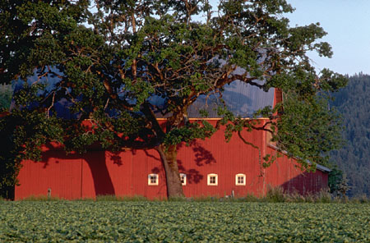Issues & Opportunities

Prior to the development of the preliminary goal statements a series of educational sessions where utilized to inform participants of planning principals, expert opinion of growth impacts and to generate a detailed list of Issues and Opportunities. By using the strengths, weaknesses, opportunities and threats (S.W.O.T.) facilitation methodology, participants in four sub-working groups identified what they perceive to be Rushford's predominant issues. The four working groups where assembled to focus on specific topical subject matter. These groups dealt with 1) Population, Housing & Economics, 2) Transportation, 3) Agriculture, and 4) The Natural Environment.

Town of Rushford
Issues & Opportunities - S.W.O.T. Summary

Natural Environment Working Group
Issues | Opportunities
Uncontrolled development | Water system (river: creeks: lakes: wetlands)
Housing growth | Recreation availability
Minimal economic contributions by tourists | River in Eureka
Boats are too loud | The pond in Waukau
Boats wash out the shoreline | The nature preserve
Dangerous boat speeds on the river | Last of the "good" riverbank
Development limiting waterfowl habitat | Farmlands for wildlife
Loss of wetlands | Woodland protection
Ag. Runoff | Traffic control
Water quality of the Fox River | Preserve farmland for future
Shorline development | Preserve open space, prairie grasses and flowers
Local & up stream non-point source pollution | Good location & shopping available nearby
Failing septic systems | Economic contributions by tourists
Increased recreational use of the Fox River | More hunting preserve
Growth impacting wildlife corridors | Game bird preservation
Long Driveways | Control over how building is being done
Large housing and lots | Control over where building is being done
Increased cars and trips generating air pollution | Control over river traffic
Animal predators
Public hunting grounds being left littered
Trend of newcomers wanting city services
Dead animal pick up by county not occurring quickly
Trash in ditches of river roads
Too few family farms
Urban sprawl
Property tax base on land desirability rather than land use
Everybody wants beauty & peace of rural life
Narrow country roads do not accommodate high traffic volumes
Highway system not keeping up with traffic
Large corporate farms
Development pressure from Fox Valley

Agricultural Working Group
Issues | Opportunities
Low prices drive more land sales for development | No feed mill
Small farms are struggling | Medical access (vet & human)
Less productive farms | Farm industry services (support system)
Clay soils | Good economics
Only one bridge across river | Dairying is about the best deal
Lots of "wet" lands = Farmer's problems | Access roads
Farm runoff into waterways & marshes | Close to rail & highway network
Growing residential pressure | Good distribution system
Government restrictions | Lots of farmland - critical mass
Farmers and residents much opposed to development | Productive land
Conflict between farm & residential needs/wants | Holding back urban proximity
Farm taxes are too high | Low development of land (housing)(so far)
New schools = higher taxes

Transportation Working Group
Issues | Opportunities
Traffic on Hwy. 91, crossing going to Ripon | Scenic/country roads maintain rural atmosphere
Speeding through Waukau & Eureka | Well maintained for winter driving
Potential four lane improvement to Hwy. 21 would destroy some homes | Proper speed limits
More $ needed to improve/maintain quality | Good police patrol level
Some roads have more traffic than they're designed for | Clear view at intersections
School busses have difficulty on some roads/narrowness | Limited access on State roadways
Improper speed limit on River Road | Proximity to Fox cities, Omro, Berlin & Oshkosh
Too many access points on roads | Major highways go through town
Speed limit not enforced | Central location
Farm machinery versus cars & trucks | Rustic roads maintain rural atmosphere
Brush control along sides of roads | Speed limits adjustments needed in some areas due to changes
Good roads attract development
Only one bridge across river
Tree, brush and shrub trimming needed to keep roads safe/currently visibility is limited

Population, Housing & Economics Working Group
Issues | Opportunities
Aging housing base | Abundance of recreational lands and opportunities
Lack of retirement housing facility | Nearby water resources (i.e., Fox River)
Threat of dumps moving into township | River is a developable economic resource
Surface and groundwater pollution | Many employment opportunities
Next generation doesn't want to farm | Prison at Red Granite
Limited industry in Town | Profitable natural resources (i.e., water & gravel)
Development spoiling rural atmosphere | Land good for farming, hunting, and boating
Higher population could mean higher crime rate | Good rental housing
Road maintenance costs increase with sprawl | Ability to work together towards the future
Road maintenance currently marginal | Community interest in welfare of the Town
No education facilities in Town | Limited industry in Town

Issues & Opportunities
Goals, Objectives & Policy Statements

While some overlap between working group statements exist, it is clear that the Town of Rushford faces a number of issues and opportunities.

Goal #1
Throughout the remaining elements of the Comprehensive Plan, each of these issues and opportunities, as they apply, will be raised for discussion.

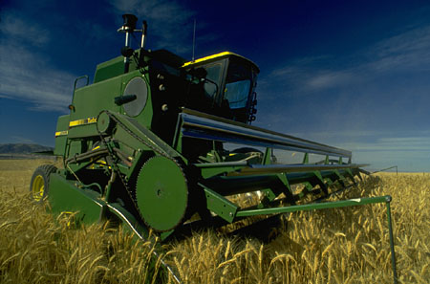
Goal #2
Appropriate solutions and implementation recommendations will be made including those involving intergovernmental relations.

Goal #3
The Town of Rushford is committed to its adopted Public Participation Plan. On going public input through multiple venues and forms will continue throughout the planning process.

Goal #4
The Town of Rushford's Comprehensive Plan will be a living/working document. As new issues arise methods for incorporating them into the plan will be followed so that the plan remains current with changing community needs. At a minimum the Comprehensive Plan shall be up dated once every five (5) years as required by law.

TOWN OF RUSHFORD
Issues & Opportunities Planning Process

On-going Community Outreach Assistance
Community Survey
Town Hall Findings Meeting
Organize Committee(s)
Value(s) Identification
Education
Priority Issues
Vision Statement
Goals
TOWN OF RUSHFORD
ISSUES & OPPORTUNITIES ELEMENT

Town of Rushford, Comprehensive Land Use Planning Committee Visioning Report. October 18, 1999. Mike Koles UWEX - Winnebago County.
Town of Rushford, Community Profile Report. Vierbicher Associates, Inc. January 2000.

